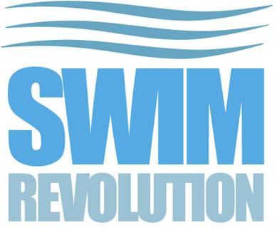 New Swimmer Registration Form

First Name
Surname
House Name of Number
Street
Address 1
Address 2
Postcode
Contact Telephone
Email Address
Emergency Contact Name
Emergency Contact Telephone
Allergies, Medical Conditions and Medication
How did you hear about Swim Revolution?
Estimated 400m Front Crawl Time (mm ss)
Please read carefully and answer each one honestly
Has your Doctor ever said that you have a heart condition and that you should not do physical activity unless recommended by a Doctor? | Yes / No
Do you feel pain in your chest when you do activity? | Yes / No
In the past month have you had any chest pain whilst doing physical activity? | Yes / No
Do you lose your balance because of dizziness or do you ever lose consciousness? | Yes / No
Is your Doctor currently prescribing drugs for blood pressure or a heart condition? | Yes / No
Do you know any reason why you should not do physical activity? | Yes / No
If you have answered yes to any of the above questions you will be required to provide a letter from your Doctor confirming you are able to participate in group swim sessions involving some high intensity training before attending your first session
Do you have any other injuries or medical conditions that may be worsened by physical activity or affect your ability to take part in physical activity – If yes please provide details below: | Yes / No
I agree that I train at Swim Revolution coached swim session at my own risk and it is my responsibility to see medical advice to ensure it is safe for me to join the sessions. I am also aware that, while every care is taken to minimise the risk of injury or accidents, I accept responsibility for my own safety. I accept that I will not hold Swim Revolution responsible for any injury, loss or damage at any time
Name…………………………. Date…………………………………

